APS Annual Program Viability Reporting Guide

Please note that the data presented below is not your institution’s data. This was created using a demonstration site.
From the APS Homepage, access the Program Analytics Dashboard by clicking on “Academic Performance Solutions Home” at the top left and selecting Program Analytics from the drop-down:
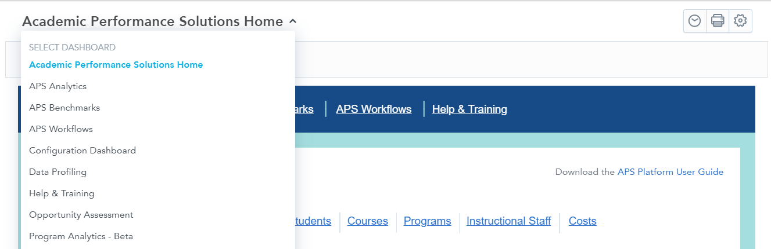

3-Year Enrollment Trend and Fall-to-Fall Retention
Before looking at any data, use the filters to get to the level of granularity that you need. You can use these filters to isolate a specific department, degree, major, and/or program. Please note the APS definition of program: a pedagogical track that students follow in order to attain a credential in their chosen field of study. Programs in APS will always follow the following format: Degree + Major. For example, Bachelor of Arts – English.
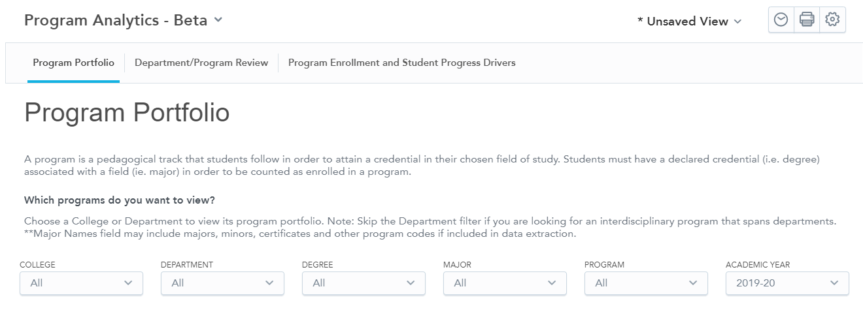
In the below example, I’ve set my department filter to just look at programs within the Political Science department:
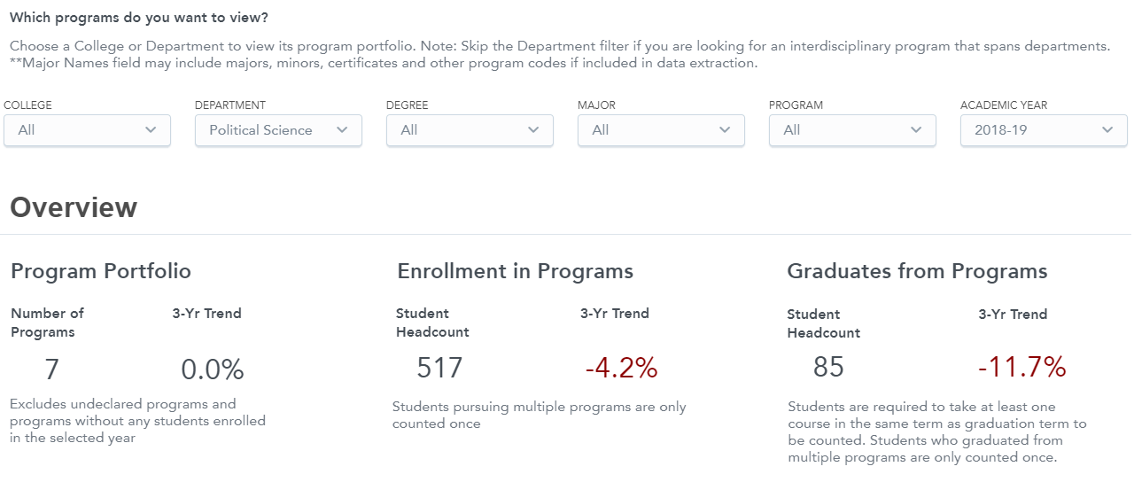
The topline of data here tells me that my Political Science department has 7 programs associated with it. 517 students were pursing a program within the Political Science department and 85 students graduated from a program in the Political Science department. When I scroll to the very bottom of this tab, I can see the 3-Year Enrollment Trend for each program within this department as well as the Fall-to-Fall Retention Rate for each program within this department.
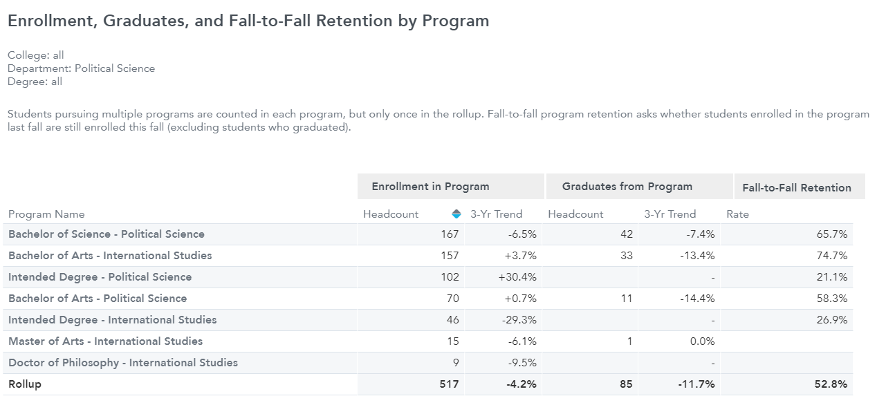
Category 1 Programs
These programs are at or above target enrollment but below target program retention.
- Migration Out Data
Move to the third tab on the Program Analytics dashboard: “Program Enrollment and Student Progress Drivers”. Set your filters as needed before analyzing any data. In the below example, I’ve isolated the Bachelor of Arts – Political Science program for deeper review.
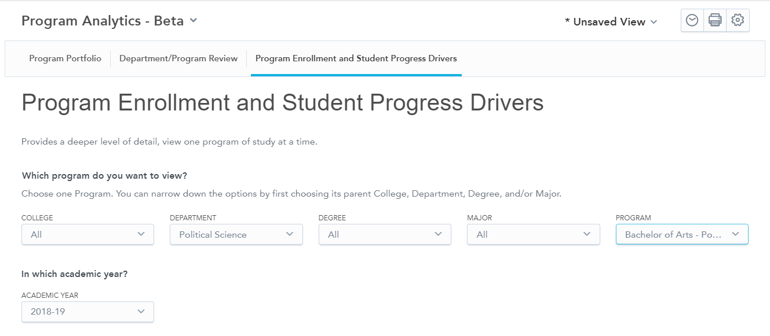
Scroll down to the Migration Out report. This report will show you the number of students who have moved out of the selected program between consecutive fall terms, broken down by where they moved. In the below example, I can see that 31 students in total migrated out of the BA – Political Science program. 7 of those students switched to another program. Click on the “…” that appears when you hover on the report and the “Download As” to download this report. Click on “View Destination Programs” to see where those students who switched to another program went.
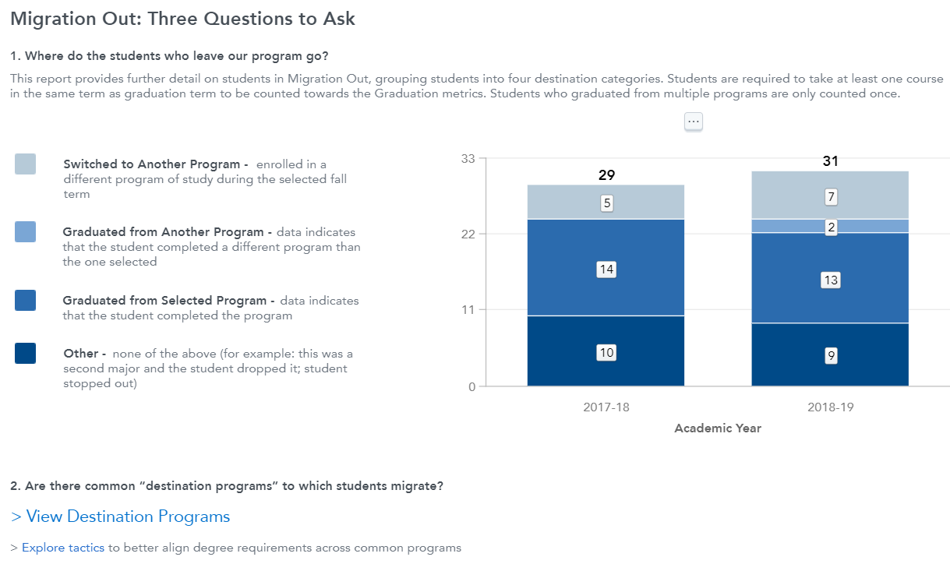
- Courses Taken by Students in Your Program (Total Across Past Three Years)
On the “Program Enrollment and Student Progress Drivers” tab, scroll down to the below report. This table will show you all of the courses that students pursing your selected program have taken over the past three years, each section of those courses that your program’s students were in, what type of course it was, what kind of instructor taught the section, how many students were in each section, and the number of students that received a D, F, or W in each section. You can use the filters above to isolate specific courses as needed. To download this report, click the “…” and then “Download As”, as shown below.
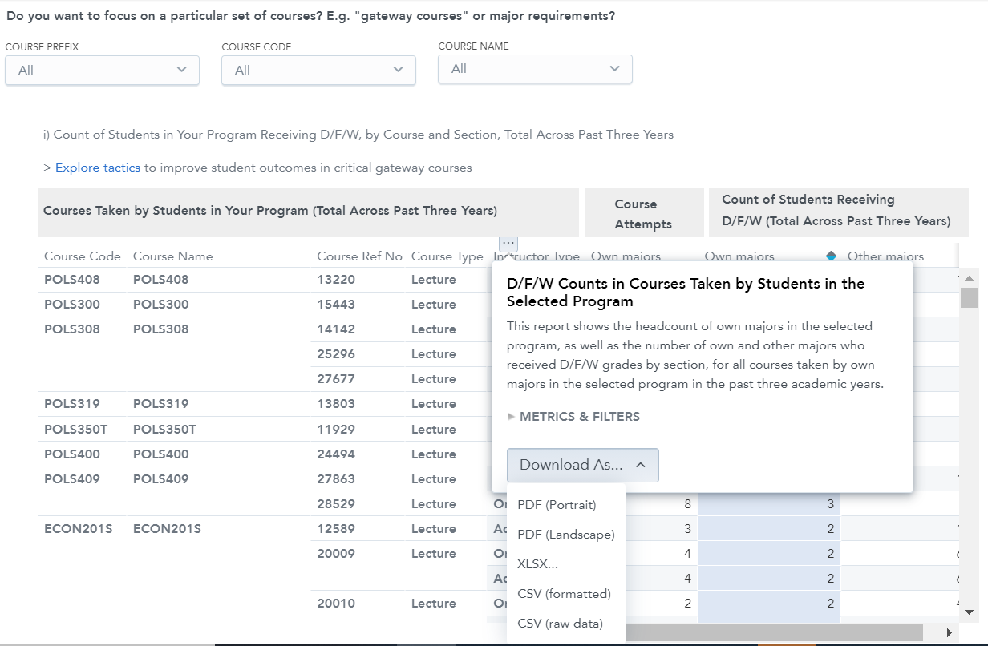
- Median Course Completion Rate by Course Level
Move to the second tab of the Program Analytics dashboard titled “Department/Program Review”. Set your filters before analyzing any data. In the below example, I have filtered to the College of Arts and Humanities, the Political Science department, the Bachelor of Arts degree, and the Political Science major. It is important that your college selection matches your department selection. If you do not select the correct college for the department you’re looking at, no data will show.
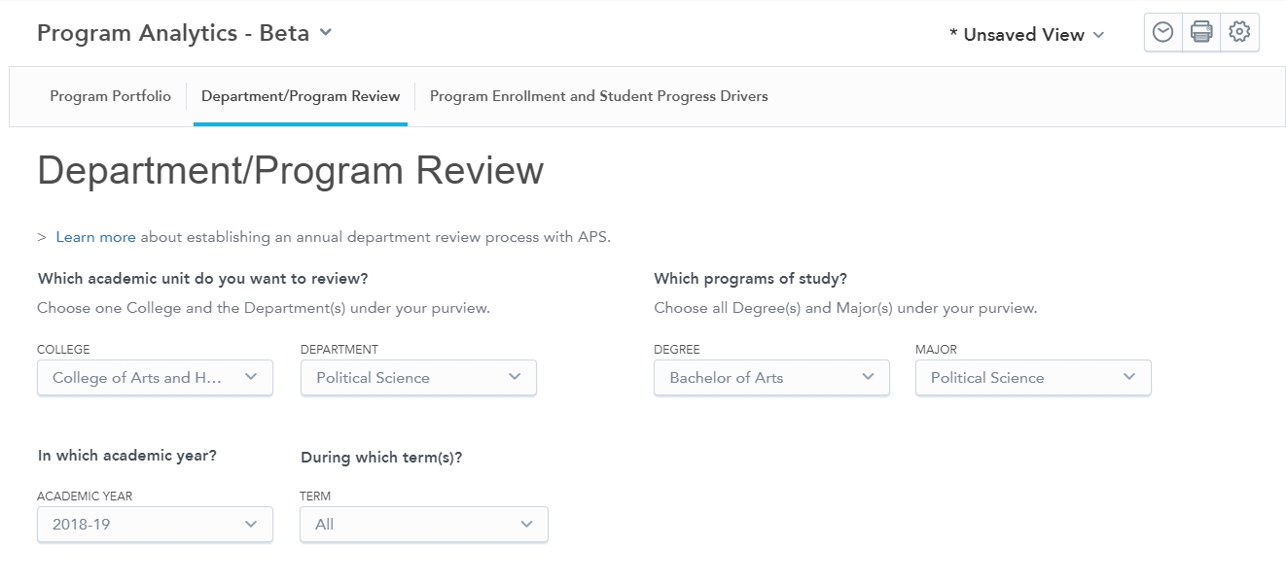
Scroll down to the “Median Course Completion Rates in the Department” analytic. Use the filter directly above to filter to the course level(s) as needed. This report will show you the 3-Year Trend of Median Course Completion Rate at the department level. You can view the change in the median course completion of your department over the last three years as compared to the change in the median course completion rate of the college over the last three years as well as view the median course completion rate of your department broken out by year. This report also shows the median course completion rate for students who are pursuing a program from outside of your department as well as the median course completion rate for students who are pursuing a program from within your department, again broken out by year. To download this report, click on the “…” that appears when you hover over each report and then “Download As”.
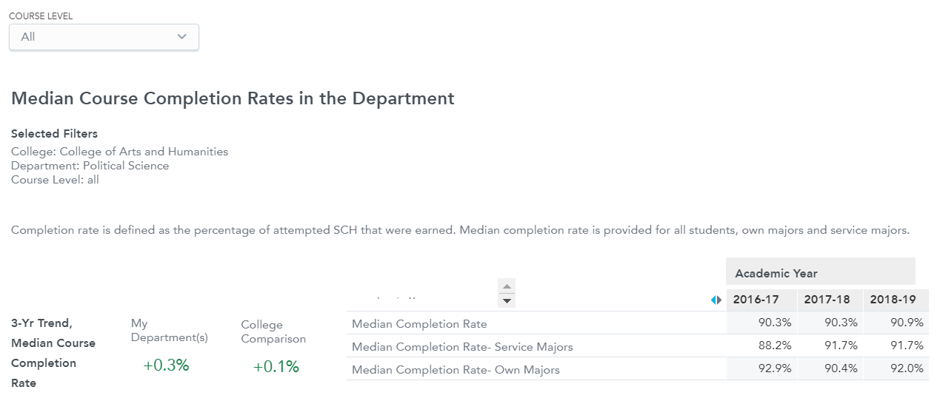
Category 2 Programs
These programs are below target enrollment but above target program retention.
- Migration Out Data
Move to the third tab on the Program Analytics dashboard: “Program Enrollment and Student Progress Drivers”. Set your filters as needed before analyzing any data. In the below example, I’ve isolated the Bachelor of Arts – Political Science program for deeper review.
Scroll down to the Migration Out report. This report will show you the number of students who have moved out of the selected program between consecutive fall terms, broken down by where they moved. In the below example, I can see that 31 students in total migrated out of the BA – Political Science program. 7 of those students switched to another program. Click on the “…” that appears when you hover on the report and the “Download As” to download this report. Click on “View Destination Programs” to see where those students who switched to another program went.
Category 3 Programs
These programs are below target enrollment and below target program retention.
- Migration Analysis
Move to the third tab on the Program Analytics dashboard: “Program Enrollment and Student Progress Drivers”. Set your filters as needed before analyzing any data. In the below example, I’ve isolated the Bachelor of Arts – Political Science program for deeper review.
Scroll down to the “Migration Analysis” report to view how many students migrated into and out of the selected program between consecutive fall terms. In the below example, I can see that 33 students migrated into the BA – Political Science program and 31 students migrated out of this program. This report can be downloaded by clicking on the “…” and “Download As”, as shown below.
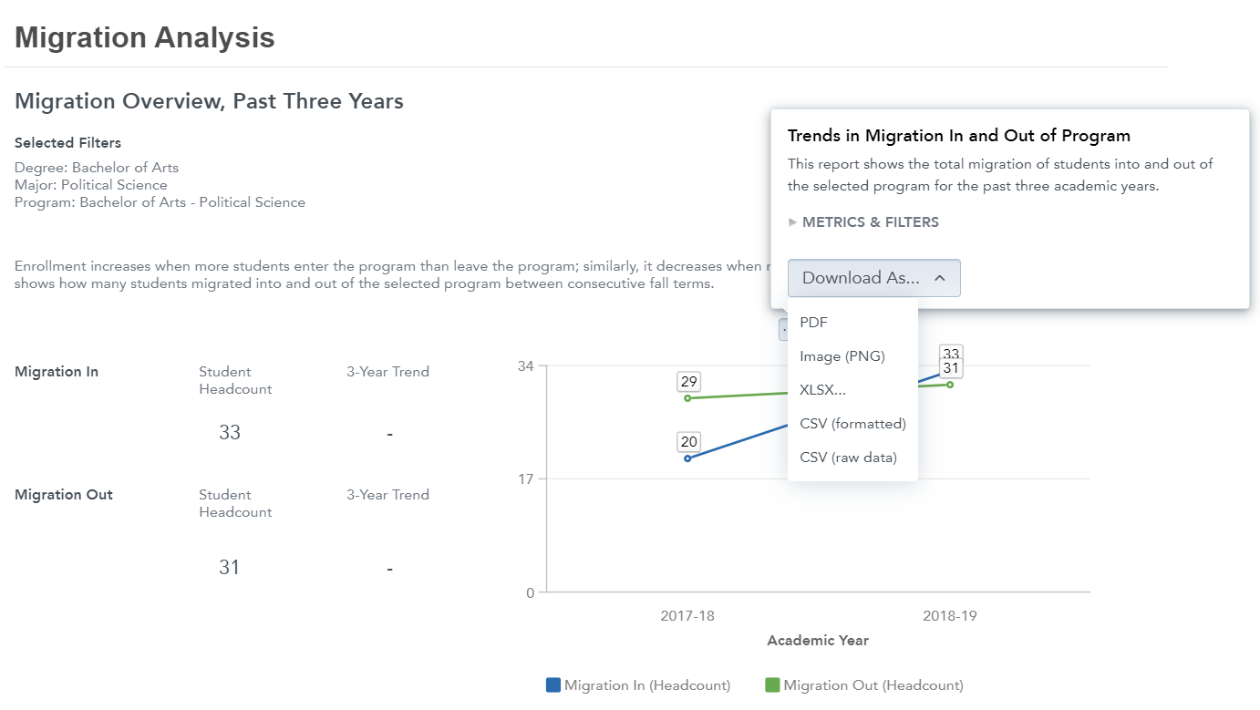
- Migration In
Scroll down to the Migration In report. This report will show you the number of students who have moved into the selected program between consecutive fall terms, broken down by where they came from. In the below example, I can see that 33 students in total migrated into of the BA – Political Science program. 13 were new to the institution and 17 switched from another program on campus. Click on the “…” that appears when you hover on the report and the “Download As” to download this report. Click on “View Source Programs” to see where those students who switched from another program came from.
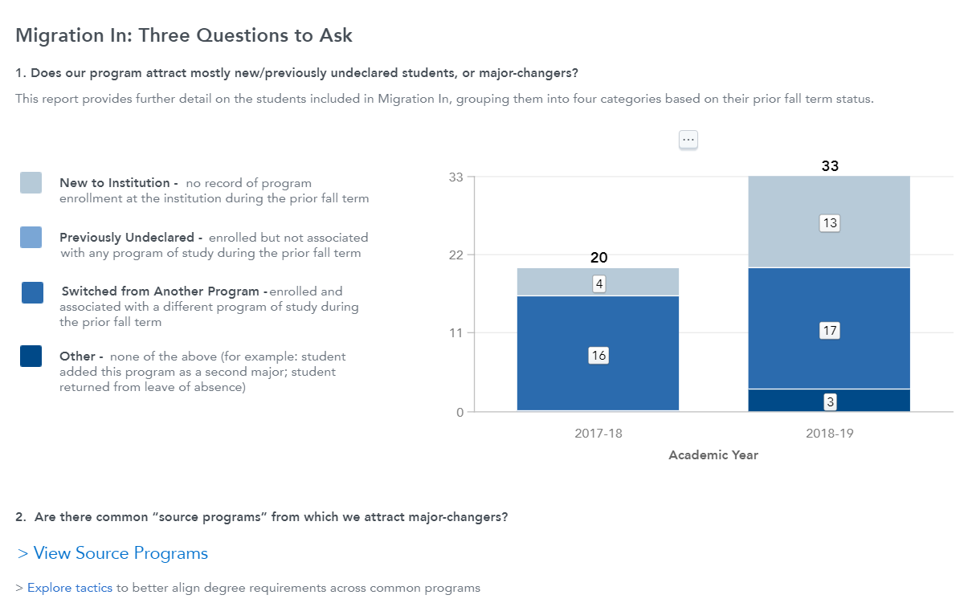
- Migration Out
Scroll down to the Migration Out report. This report will show you the number of students who have moved out of the selected program between consecutive fall terms, broken down by where they moved. In the below example, I can see that 31 students in total migrated out of the BA – Political Science program. 7 of those students switched to another program. Click on the “…” that appears when you hover on the report and the “Download As” to download this report. Click on “View Destination Programs” to see where those students who switched to another program went.
- Median Course Completion Rate by Course Level
Move to the second tab of the Program Analytics dashboard titled “Department/Program Review”. Set your filters before analyzing any data. In the below example, I have filtered to the College of Arts and Humanities, the Political Science department, the Bachelor of Arts degree, and the Political Science major. It is important that your college selection matches your department selection. If you do not select the correct college for the department you’re looking at, no data will show.
Scroll down to the “Median Course Completion Rates in the Department” analytic. Use the filter directly above to filter to the course level(s) as needed. This report will show you the 3-Year Trend of Median Course Completion Rate at the department level. You can view the change in the median course completion of your department over the last three years as compared to the change in the median course completion rate of the college over the last three years as well as view the median course completion rate of your department broken out by year. This report also shows the median course completion rate for students who are pursuing a program from outside of your department as well as the median course completion rate for students who are pursuing a program from within your department, again broken out by year. To download this report, click on the “…” that appears when you hover over each report and then “Download As”.
- 3-Year Graduation Trend
Scroll down to the “Graduates from Programs” report. This report will show you the 3-Year Trend of Graduates from your selected program(s). You can see a comparison of the change of graduates between your program(s) and the college. This report will also show the number of students who graduated from the selected program broken down by year. To download this report, click on the “…” that appears when you hover over each report and then “Download As”.
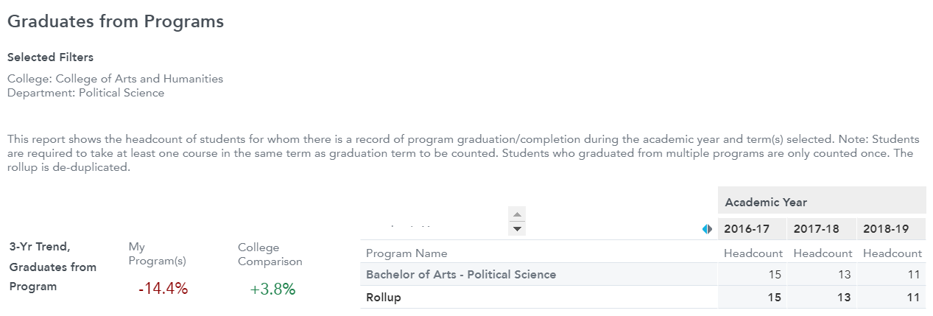
- 3-Year Trend in Attempted Student Credit Hours (SCH)
Scroll up to the “Enrollment in Courses Offered by Department” analytic. This report will show you the 3-Year Trend in Attempted SCH for the selected department(s), a comparison to the college, and a break down of attempted SCH by year. This report will also show you the percent of attempted SCH taught to majors within the select department and the percent of attempted SCH taught to majors from other departments. To download this report, click on the “…” that appears when you hover over each report and then click “Download As”. You can also view a further breakdown of other programs that are taking your department’s coursework by clicking the “Intercurricular Dependencies by Department” link.
